1.
Here a add button should include to add more items

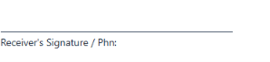
2.

Here I can able to add receiver name from input beside the signature
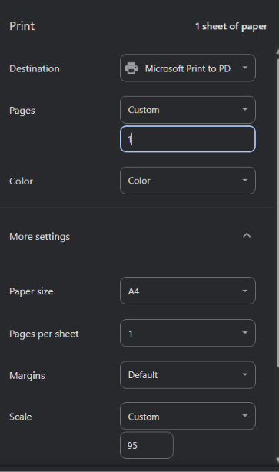

3.

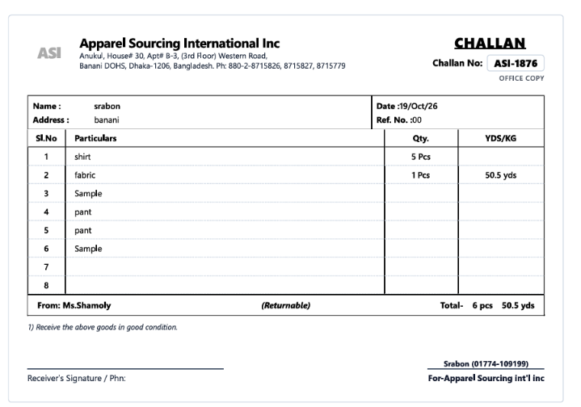
4.

Border cancel

